1. **Dependencies/ Development Environment**

Visual Studio 2013 .NET 4.5

Microsoft SQL Server 2014 (used for this project)

Microsoft Office 2010: Primary Interop Assemblies Redistributable ([Download here](https://www.microsoft.com/en-gb/download/details.aspx?id=3508))

Microsoft Office 2010

1. **Project Setup**

Once you open the solution (ATTS.ImportUtilityUI.sln), you need to reset the reference for Office interop assemblies for **ATTS.FileDataReader** project. This is because this is an activeX COM component and will have different registry information from one machine to another. See below

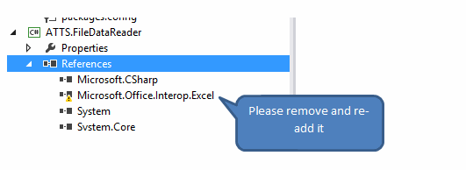

To re-add this reference, go to Add reference, under Assemblies, click Extensions and add **Microsoft.Office.Interop.Excel.** See below

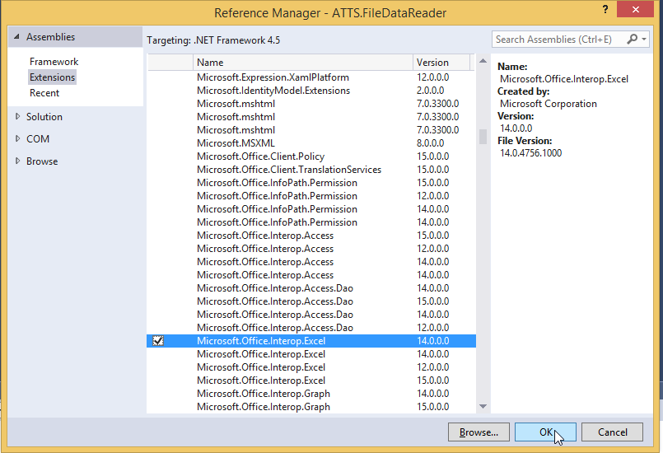

If you don’t find this, please install office interop assemblies from [here](https://www.microsoft.com/en-gb/download/details.aspx?id=3508) and then add.

1. **Database setup**

Edit App.config for **ATTS.ImportUtilityUI** project. You do not need to run the scripts, the database (**atts**) will automatically be created by the program (**Windows authentication should be enabled**). See below



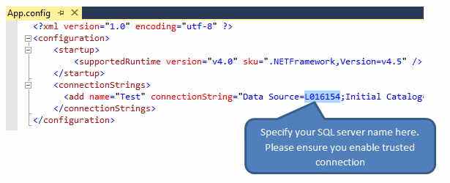

**Note**: Every time you run the code the current database will be deleted and recreated. If you want to only create the database once. Change the AttsDbContext constructor to use the CreateDatabaseIfNotExists option (if it’s there, just comment out DropCreateDatabaseAlways)

**In case windows authentication is not enabled, please edit the connection string with your SQL server credentials.**

1. **Test Data**

I have included one test CSV and Excel files (one small, one with 1m records).

You can find these in **ImportTestData** folder in project location. I intentionally put some invalid currency codes in CSV. See below

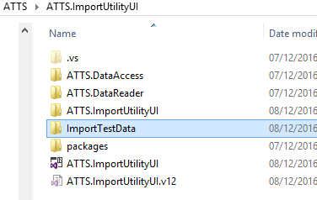

1. **Test Results**

This utility processes 10,000 excel rows within 4 minutes so 1 million rows will take approximately 6 hours to process. Since I used Excel introp to read the excel files, this isn’t great library to achieve best performance. Having said this CSV file import is much faster than excel import.

These test results were taken from this machine - **AMD A10-6880K CPU - 8GB RAM - Win8.1 64 bit Pro** and performance may slightly vary on different machine.